**Introduction to Signals and Modulation - Marking Scheme**

|  |  |  |  |  |
| --- | --- | --- | --- | --- |
|  | Registration  Number | Surname | Forename | % Contribution |
| Student 1 | 000839875 | Turon | Kacper | 25% |
| Student 2 | 000871936 | Young | Jack | 25% |
| Student 3 | 000878481 | Kallon | Kevin | 25% |
| Student 4 | 000874782 | Basharat | Usman | 25% |

|  |  |  |
| --- | --- | --- |
| **Task** | **Mark** | **Grade** |
| Signal Bandwidth and Quality - Student has completed both tables and accurately measured signal bandwidths and correctly calculated percentage of the transmitted signal to the original. | 12 |  |
| Periodic Signals (Audacity) - Student has completed the four spectrum plots, identified the errors in the combined sinusoidal signals' spectrum when compared to the equation and plotted the correct spectrum for the equation. | 12 |  |
| Periodic Signals (Pico Scope) - Student has demonstrated ability to accurately read signal metrics from the Pico Scope instrument, by correctly completing the table of, Voltage, Frequency and Equations. | 12 |  |
| Introduction to Modulation - Student has demonstrated the ability to use the Waveform Generator and Pico Scope equipment, by correctly completing the table of time and frequency domains for sinusoidal, square and audio amplitude modulated waveforms. Student should state their reasons for choosing  the transmission Bandwidth for each signal. | 12 |  |
| Sinusoidal and Audio Signal Demodulation - Student has accurately completed time and frequency domain plots, and demodulated the audio signal. | 12 |  |
| Radio Spectrum - Student has identified three or for radio transmissions on a plot of the spectrum, and tabulated these in a table. | 12 |  |
| Radio Spectrum - Student has demonstrated, the effect of a tuning circuit on a plot of the spectrum. | 12 |  |
| Reflection | 16 |  |
| Total | 100 |  |

COMP1587 Communication Systems

Week 5 Laboratory

Introduction to Signals and Modulation

Usman Basharat - 000874782

Kevin Kallon - 000878481

Jack Young - 000871936

Kacper Turon - 000839875

Contents

Abstract 3

Introduction 3

Methods and Materials (or Equipment) 3

Equipment/Materials used: 3

Software used: 3

Experimental Procedure 3

Results 4

Task 1 - Signal Bandwidth and Quality 4

Task 2 - Periodic Signals (Audacity) 4

Task 3 - Periodic Signals (Pico Scope) 6

Task 4 - Introduction to Modulation 6

Task 5 - Sinusoidal and Audio Signal Demodulation 7

Task 6 - Radio Spectrum 7

Discussion 9

Task 7 – Reflection 9

Conclusion 11

References 12

# Abstract

This document explains exercises and research we did to go through laboratory session. We explain how we measured quality of different audio files from different sources using audacity. The most important part of this laboratory was to teach us how to compare different audio files, compare bandwidths how to calculate equation from plotted graph, how to use oscilloscope and Pico Scope and reflect on results. We have managed to operate oscilloscope and gather from it information such as spectrum of sine waves, square waves audio files. We also used Pico Scope and a wire to capture frequencies from different radio carriers and using United Kingdom Frequency Allocation table we were able to identify them.

# Introduction

In this report, we will explain how to use audacity to examine the quality of audio file as well as check the signal quality and later on plot it on spectrum graph. For the rest of the exercises we used Pico Scope and oscilloscope which measures constantly varying signal and plots a two dimensional graphs. We explain how we modified and changed settings of oscilloscope and Pico Scope to achieve results expected in our exercises. We measured peak voltage, frequency and we calculated how equation would look like for certain graphs.

# Methods and Materials (or Equipment)

## Equipment/Materials used:

* Guide (Greenwich, 2015)
* BNC terminated coaxial cable
* Two BNC crocodile clips leads
* BNC T piece connector
* Audio plug to BNC cable
* Headphones
* CB Speaker
* 7m wire
* 1m wire
* Diode
* Capacitor
* Terminal Block
* Waveform Generator
* Pico Scope 3206
* White paper
* Screwdriver

## Software used:

* Audacity Software
* Pico Scope Software

# Experimental Procedure

For this laboratory session, we followed a guide provided by the University of Greenwich that told us what to do step by step. All steps were followed; no extra steps were taken when doing the tasks that were based on the guide.

# Results

Table - Quality of the transmitted signal compared to the original signal

## Task 1 - Signal Bandwidth and Quality

|  |  |  |  |  |  |
| --- | --- | --- | --- | --- | --- |
| **Artist** | **Original Audio** | **Telephone** | **AM Radio** | **DAB Radio** | **FM Radio** |
| Antonio Vivaldi | 100% | 60% | 70% | 90% | 80% |
| Dave Brubeck | 100% | 50% | 60% | 85% | 85% |
| Enid Blyton | 100% | 65% | 65% | 85% | 85% |
| Nickelback | 100% | 60% | 60% | 90% | 80% |

|  |  |  |  |  |  |  |  |  |  |  |
| --- | --- | --- | --- | --- | --- | --- | --- | --- | --- | --- |
| **Artist** | **Original Audio** | | **Telephone** | | **AM Radio** | | **DAB Radio** | | **FM Radio** | |
|  | Signal Bandwidth | % of Original | Signal Bandwidth | % of Original | Signal Bandwidth | % of Original | Signal Bandwidth | % of Original | Signal Bandwidth | % of Original |
| Antonio Vivaldi | 15000 | 100% | 3385 | 22.56 | 6938 | 46.25 | 13800 | 92 | 14215 | 94.7 |
| Dave Brubeck | 20723 | 100% | 3385 | 16.33 | 6981 | 53.69 | 13873 | 66.94 | 14943 | 72.11 |
| Enid Blyton | 15586 | 100% | 3385 | 21.72 | 7366 | 47.26 | 13916 | 89.29 | 14901 | 95.61 |
| Nickelback | 22000 | 100% | 3385 | 15.39 | 6981 | 31.73 | 13916 | 63.25 | 14986 | 68.12 |

Table - The proportion of the spectrum where there is the most energy. This is then calculated against the original audio transmitted

## Task 2 - Periodic Signals (Audacity)

|  |  |  |
| --- | --- | --- |
| **Signal** | **Equation f(t) = A sin (2.π.f.t)** | **Spectrum** |
| [1 kHz Sinusoidal](http://staffweb.cms.gre.ac.uk/~sp02/Signals&Modulation/wavfiles/Sine1kHz.wav) | f(t) = 1 sin (2.π.1000.t) |  |
| [3 kHz Sinusoidal](http://staffweb.cms.gre.ac.uk/~sp02/Signals&Modulation/wavfiles/Sine3kHz.wav) | f(t) = 1/3 sin (2.π.3000.t) |  |
| [5 kHz Sinusoidal](http://staffweb.cms.gre.ac.uk/~sp02/Signals&Modulation/wavfiles/Sine5kHz.wav) | f(t) = 1/5 sin (2.π.5000.t) |  |
| [1 kHz, 3kHz and 5kHz Sinusoidal Combined](http://staffweb.cms.gre.ac.uk/~sp02/Signals&Modulation/wavfiles/ThreeSines.wav) | f(t) = 1 sin (2.π.1000.t) + 1/3 sin (2.π.3000.t) + 1/5 sin (2.π.5000.t) |  |

Table – Sinusoidal Signals

|  |  |  |  |  |
| --- | --- | --- | --- | --- |
| **Signal - Oscilloscope View** | **Signal - Spectrum View)** | **Peak to Peak Voltage** | **Frequency** | **Equation** |
| [Signal α](http://staffweb.cms.gre.ac.uk/~sp02/Signals&Modulation/PicoScopeFiles/OscilloscopeSignalA.psdata) | [Signal α](http://staffweb.cms.gre.ac.uk/~sp02/Signals&Modulation/PicoScopeFiles/SpectrumSignalA.psdata) | 10 V | 2kHz | f(t) = ½ sin (2.π.2000.t) |
| [Signal β](http://staffweb.cms.gre.ac.uk/~sp02/Signals&Modulation/PicoScopeFiles/OscilloscopeSignalB.psdata) | [Signal β](http://staffweb.cms.gre.ac.uk/~sp02/Signals&Modulation/PicoScopeFiles/SpectrumSignalB.psdata) | 3.33 V | 6kHz | f(t) = 1/6 sin (2.π.6000.t) |
| [Signal γ](http://staffweb.cms.gre.ac.uk/~sp02/Signals&Modulation/PicoScopeFiles/OscilloscopeSignalC.psdata) | [Signal γ](http://staffweb.cms.gre.ac.uk/~sp02/Signals&Modulation/PicoScopeFiles/SpectrumSignalC.psdata) | 1.984 V | 10kHz | f(t) = 1/10 sin (2.π.10000.t) |
| [Signal δ](http://staffweb.cms.gre.ac.uk/~sp02/Signals&Modulation/PicoScopeFiles/OscilloscopeSignalD.psdata) | [Signal δ](http://staffweb.cms.gre.ac.uk/~sp02/Signals&Modulation/PicoScopeFiles/SpectrumSignalD.psdata) | 10 V | 2kHz | f(t) = ½ sin (2.π.2000.t) |

## Task 3 - Periodic Signals (Pico Scope)

Table – Pico Scope Signals

## Task 4 - Introduction to Modulation

|  |  |  |  |
| --- | --- | --- | --- |
| **Signal** | **Time Domain** | **Frequency Domain** | **Transmission Bandwidth** |
| Sine |  |  | 15 kHz |
| Square - This represents Data. |  |  | 17 kHz |
| Audio -  [How You Remind Me](http://staffweb.cms.gre.ac.uk/~sp02/Signals&Modulation/AudioFiles/Telephone/Nickelback%20-%20How%20You%20Remind%20Me%20-%20POTS.wav) |  |  | 19 kHz |

Table – Signals over time and frequency

## Task 5 - Sinusoidal and Audio Signal Demodulation

|  |  |  |
| --- | --- | --- |
| **Diode Direction** | .Diode | .Diode |
| **Time Domain** |  |  |
| **Frequency Domain** |  |  |

Table – Time and frequency of different diode directions

## Task 6 - Radio Spectrum

|  |  |
| --- | --- |
| **Carrier Frequency** | |
| **Carrier Frequency** | **Transmission Identify** |
| 10kHz | RADIONAVIGATION UK1 |
| 18kHz | FIXED MARITIME MOBILE 5.57 UK2 |
| 75kHz | FIXED MARITIME MOBILE 5.57  RADIO NAVIGATION 5.60 |
| 138kHz | FIXED MOBILE RADIOLOCATION SPACE RESEARCH |

Table – Detecting radio waves and identify the transmission

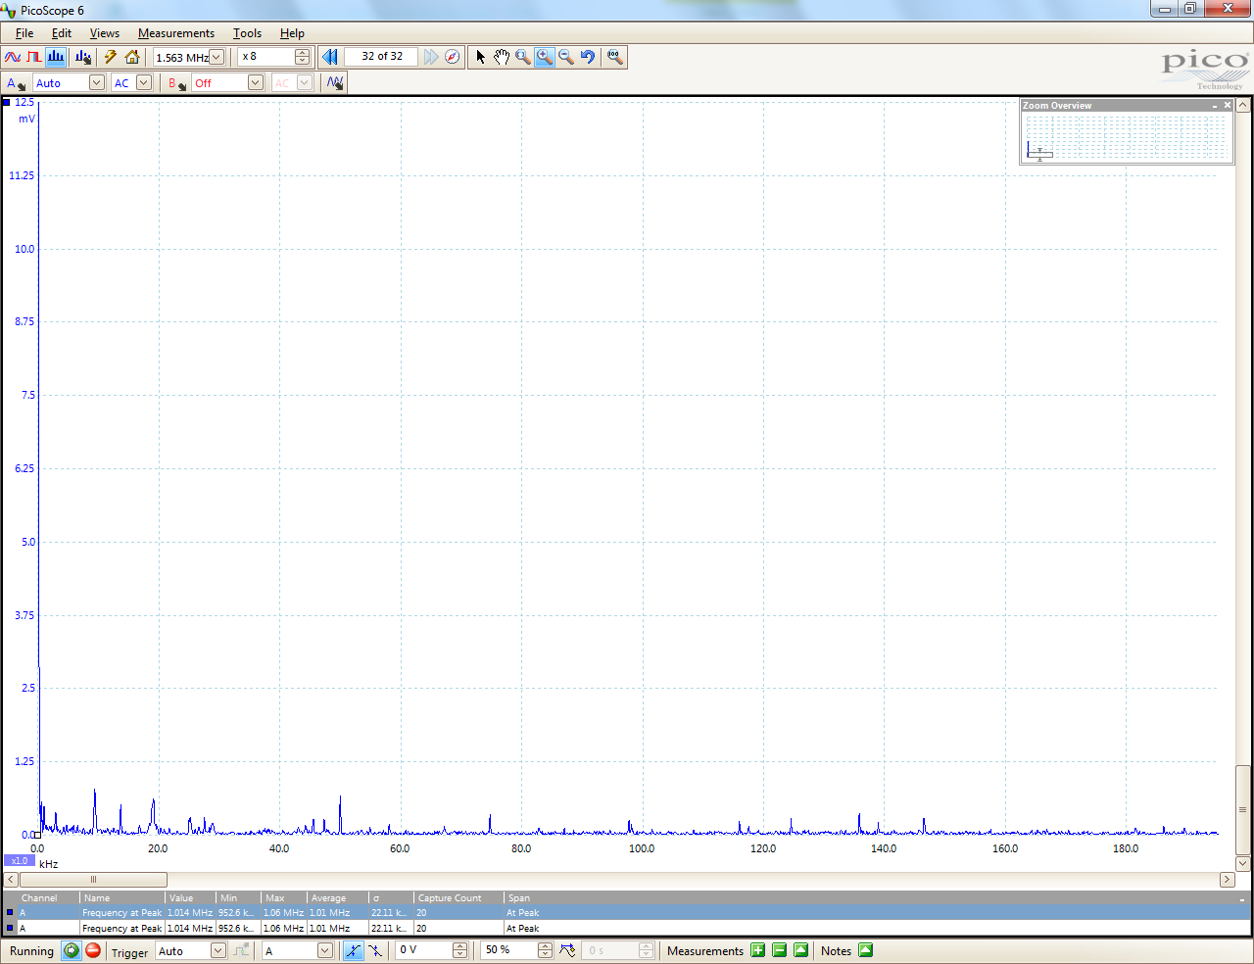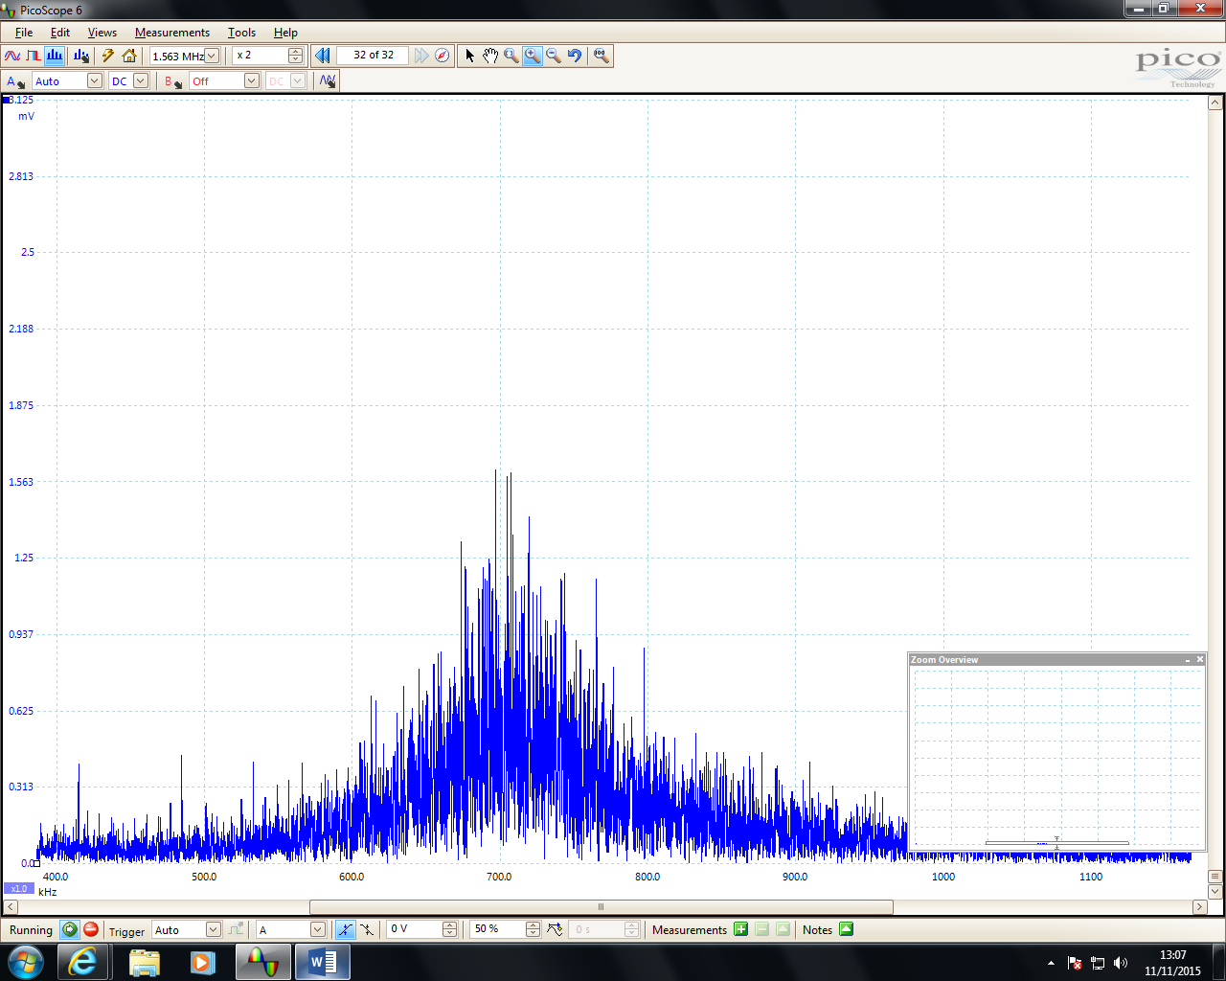

Figure – Radio spectrum

Figure a – Radio spectrum with antenna and adjustable coil to move the signal

# Discussion

Figure 2b – Radio spectrum with antenna and adjustable coil to move the signal

## Task 7 – Reflection

This laboratory session helped us understand different waves generated by the waveform generator. We were using different software like Audacity and Pico Scope to view the output of the signals. This helped us as a group to learn how different properties of the waveform generator affect the output of the signal as it was visually changing in front of us, this helped us in our degree as we now know more about signals than what we did before.

For Task 1, all we had to do is listen to each of the tracks that were given. All were different and we had to predict how each one sounded like to its original track. Firstly, the order we listened each track is the original track, Telephone, AM Radio, DAB Radio and FM Radio track. As we went along, each person listened to each track and predicted the results. The results of these were that the last two sounded similar to its original track. However, the first two were not that clear. This gave us an insight to what we can predict each track. We all understood that each of these examples represented the quality of the telephone, AM Radio, DAB Radio and FAM Radio. Referring back to Table 1, this shows the results we predicted. As shown, FM Radio and DAB Radio were near enough its Original; however, Telephone and AM Radio were not as clear. The next part of Task 1 used Audacity software again to find out the signal bandwidth of each of the soundtracks. We had to download each track, and use Audacity software to open it up and check its signal bandwidth of each track. We knew that from what we predicted, it was either DAB Radio or FM Radio to be the highest. Once we completed this, we calculated the percentage of each one from its original track. The only critical note is that it took a very long to download and check each one, but we followed the manual and we completed this task. We found both of Table 1 and Table 2 pretty simple as the manual told us everything to do. It was clear. To improve this task, I would avoid downloading each track, because we struggled at first to download it, but we got it at the end. For next year students, they can already have a file within it to download only and that can save more time than before.

For Task 2, we used Audacity software to find out the signals of the 1 kHz, 3 kHz, 5 kHz and all of them combined to produce a spectrum which we then recorded. In addition, we had to ensure that the signals relates to the spectrum we recorded. Referring this back to Table 3, it shows a clear example of how accurate the spectrum is. For example, the 1 kHz we recorded, it should be on the 1 kHz line to ensure that the signal we have recorded is correct. We also needed to ensure that we understand the equation and how it relates to the spectrum. We felt that this Task was straight forward, because everything was shown on the manual. All we did is followed the manual, screenshot the results and completed the task.

For Task 3, we had to download each of the files and using Pico Scope software; we simply recorded the results shown on Table 4. We used a Pico Scope using a USB Cable to connect to the computer and we had to record the peak-to-peak voltage and frequency. We all understood how the equation is used. Therefore, all that we had to do is use the equation that is used on Table 3, plot it with its correct units, and fill the equations in. By doing this, we completed the table. As said before, for improvements, downloading each signal takes a long time to do. Just to make it a lot easier, we can have one file containing all of them.

For Task 4, we had to vary the frequency of the modulator and record the effect as shown in Table 5. Each signal is different and each signal had different set up instructions to complete. As for any other task, one person of the group was reading out the settings of the each Waveform Generator setup and the other was pressing the key as soon as I read it out. To make sure, we had the rest two members keeping sure that the settings were correct in order to get it correct. We had correctly completed the first two, but once we went on to the third one and we played the music, it had no effect on the result. We kept reading the instructions of the output setup and everything seemed to be connected. However, when we recompleted the Audio Waveform Set up Instructions, we realised that we missed one instruction for this to be complete. From then on, we made sure that every instruction was not to be missed. Referring back to Table 5, we got the transmission bandwidth by getting the highest frequency minus the lowest frequency we got. Therefore, the results are shown on Table 5. For this Task especially, we did not finish it on the time we had to complete during the first-week laboratory. We came back in our own time to do this task. This shows that we were keen for this to be complete.

For Task 5, we had to use BNC probe clip leads to use to complete the diagram. As we progressed with this task, we noticed that we had to change the diode from one side to another using the black to indicate, which side it is at. Referring to Table 6, it clearly shows that the direction of the diode has been changed effectively. There was a little confusion to how to change it, but all confusion was solved by referring to the manual and it was made clear that we had to change the direction from one end to another. We had to make sure that the direction it is facing; it was the right one. If not, it would have been confusing to get the results. We had to check that the settings were correct. To check we did not make a mistake, one person of the group was reading out the settings of the Waveform Generator and the other was pressing the key as soon as I read it out. To make sure, we had the rest of the two members keeping sure that the settings were correct in order to get it correct. We felt that this task was simple and we completed it with full understanding so therefore, there is no improvements.

For Task 6, it was quite confusing at first of what we had to do as the diagram was not presented in a way which we could easily understand. We soon realised later that we needed a capacitor to connect the two sides of the terminals together which also was not connected to the BNC probe clip. The 7mwire which was hanging out the window and one end of the coil was connected to one side and the other coil was connected to the other side of the terminal. The BNC wire was corrected connected to the Pico Scope which was connected to the computer. On the computer, we saw a substantially bigger signal than the signal we received without the coil. Upon moving the coil across, we were able to move the strength of the signal up and down which changed the frequency of the signal being received, this is shown in Figure 2a and 2b.

# Conclusion

To conclude, we were able to do all the tasks we were assigned in the laboratory and understand how to operate an oscilloscope to get the results we were expecting. We have also managed to use Pico Scope software to check the quality of different audio files, bandwidth and to get spectrum of those files.

# References

Greenwich, University of. (2015) *File Transfer Protocol*, 1st ed, Greenwich, University of Greenwich, [online] Available at: <http://staffweb.cms.gre.ac.uk/~lg47/lectures/COMP1587/COMP1587Lab4.pdf>

(Accessed 27 October 2015).